

WICKLOW COUNTY COUNCIL

WINTER SERVICE PLAN 2022-2023

###### _______________________________________________________________________

###### VERSION: Final

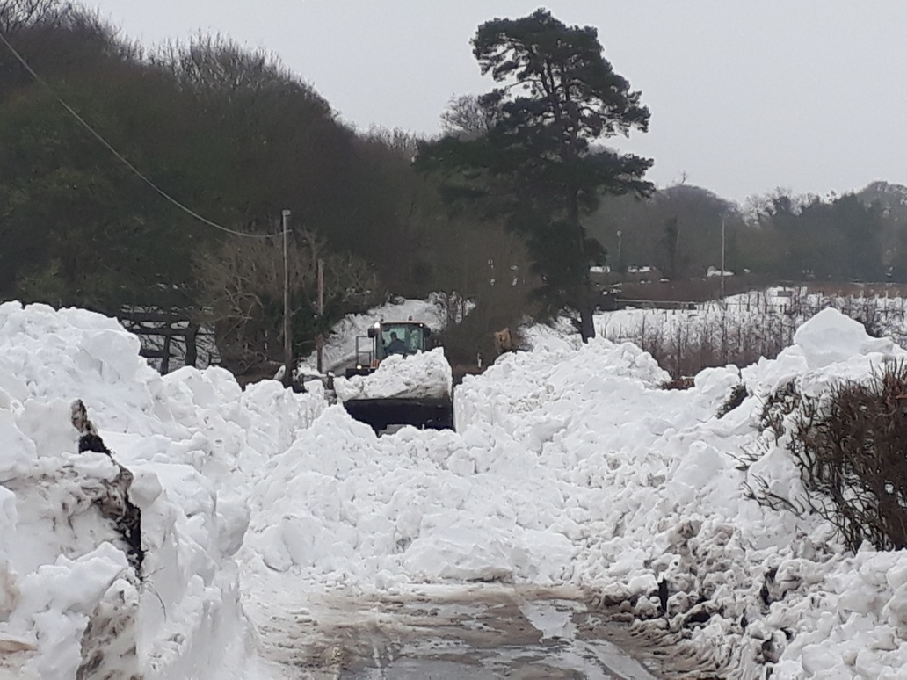

###### 

###### TRANSPORTATION, WATER & EMERGENCY SERVICES DIRECTORATE,

###### WICKLOW COUNTY COUNCIL,

###### COUNTY BUILDINGS,

###### WICKLOW TOWN,

###### CO. WICKLOW.

**December 2022**

Contents

1.0 DOCUMENT CONTROL 3

2.0 APPROVAL LIST 3

3.0. DISTRIBUTION LIST 4

3.1 Internal Distribution list 4

3.2 External Distribution 5

4.0 PURPOSE OF SCOPE 5

5.0 POLICY 5

Priority 1 (Red Routes). 5

Priority 2 (Blue Routes). 6

Priority 3 (Unmarked Routes). 6

Footpaths 7

6.0 OVERALL MAP OF SERVICE PLAN AREA 7

7.0 RESPONSIBILITIES 7

7.1 Winter Services Manager 7

7.2 Winter Service Duty Engineers 8

7.3 Municipal District Engineers 9

7.4 General Service Supervisors. 9

7.5 Drivers 10

8.0 CONTACT DETAILS 10

9.0 SUPPLEMENTARY RESOURCES 10

10.0 TII DECISION MATRIX 11

11.0 TII TREATMENT MATRIX 12

12.0 PLANT, VEHICLES AND EQUIPMENT 14

13.0 WINTER SERVICE DEPOTS 14

14.0 MATERIALS AND SPARES 15

14.1 Salt 15

14.2 Grit 15

14.3 Fuel & Plant 15

15.0 MMaRC AREA - GSJ CONSORTIUM AND BAM PPP 15

APPENDIX 1 – WINTER SERVICE MAP 16

**APPENDIX 3 – WICKLOW COUNTY COUNCIL DUTY ENGINEERS ROSTER** 18

APPENDIX 4 - DRIVER’S ROSTER 19

APPENDIX 5 - CONTACT DETAILS 21

APPENDIX 6 - PLANT; VEHICLES AND EQUIPMENT 25

APPENDIX 7 - WINTER SERVICE DEPOT DETAILS & LOCATION MAP 28

APPENDIX 8 – Wicklow Co. Co. Coronavirus Risk Assessment 30

Activity 1 **Hazard and Risk Assessment.** 330

Activity 2 Monitoring of known Case Reporting on Covid 19 …………………………………………….………41

Activity 3 Public Health Measures to mitigate the effects of Covid 19………………………………...…….42

Activity 4 Knowing the symptoms of Covid- 19 ………………………………………………………………..45

Activity 5 Delivering Essential Services in the event of a Covid 19 Outbreak …………………………46

Activity 6 Need to work with other PRA's during Covid 19 ………………………………………………48

Activity 7 Working on site ……………………………………………………………………………………49

Activity 8 Working within Council offices……………………………………………………………………51

Activity 9 Travelling in work vehicles, operation of mobile plant - Covid 19 ……………………………54

# 1.0 DOCUMENT CONTROL

This document “Wicklow County Council Winter Service Plan 2022 to 2023 defines the methodology by which Wicklow County Council intends to deliver its Winter Maintenance Programme for Winter Season of October 2022 to April 2023.

Any issues relating to the content of this plan should be referred to the Winter Services Manager for their attention.

A condensed non-sensitive version of this document may be made available on the Wicklow County Council website for public information.

|  |  |  |  |
| --- | --- | --- | --- |
| **Revision** | **Status** | **Revision Details** | **Issue Date** |
| 1.0 | Draft Issue | Issued for Review | 12th December 2022 |
|  |  |  |  |
|  |  |  |  |
|  |  |  |  |

# 2.0 APPROVAL LIST

This document has been circulated internally to relevant Staff for review prior to final approval.

|  |  |  |  |
| --- | --- | --- | --- |
| **Role** | **Name** | **Signature** | **Date** |
| Director of Services for Transportation, Water & Emergency Services | Leonora Earls |  |  |
| Senior Engineers | Michael Flynn  John Bowes |  |  |
| Winter Service Manager | Pat Clarke |  |  |

# 3.0. DISTRIBUTION LIST

## 3.1 Internal Distribution list

This document shall be circulated to the following internal Staff in Wicklow County Council:-

| **Issued To** | **Position** | **Location** |
| --- | --- | --- |
| Leonora Earls | Director of Services, Transportation, Water & Emergency Services | Station Rd, Wicklow Town |
| Helena Dennehy | Senior Executive Officer, Transportation, Water & Emergency Services | Station Rd, Wicklow Town |
| Michael Flynn | Senior Engineer, Roads | Station Rd, Wicklow Town |
| John Bowes | Senior Engineer, Roads | Station Rd, Wicklow Town |
| Pat Clarke | Winter Service Manager | Station Road, Wicklow |
| Conor Carty | Duty Engineer | Station Rd, Wicklow Town |
| Declan O’Brien | Duty Engineer | Station Rd, Wicklow Town |
| Brian O’ Sullivan | Duty Engineer | Station Rd, Wicklow Town |
| Aoife Cashman | Health & Safety Officer | Station Rd, Wicklow Town |
| Pat Byrne | Baltinglass Municipal District Engineer | Baltinglass MD Office |
| Dermot Graham | Executive Engineer, Baltinglass Municipal District | Baltinglass MD (Tinahely sub office) |
| Kevin Scanlon | Wicklow Municipal District Engineer | Wicklow MD Office |
| Avril Hill | Arklow Municipal District Engineer | Arklow MD Office |
| Ruairi O’Hanlon | Greystones Municipal District Engineer | Greystones MD Office |
| Liam Bourke | Bray Municipal District Engineer | Bray MD Office |
| Aidan Dempsey | Chief Fire Officer | Bray Fire Station |
|  |  |  |

## 3.2 External Distribution

| **Issued To** | **Position** | **Organisation** |
| --- | --- | --- |
|  | Winter Services Manager | Wexford County Council |
|  | Winter Services Manager | Carlow County Council |
|  | Winter Services Manager | Kildare County Council |
|  | Winter Services Manager | South Dublin Co.Co. |
|  | Winter Services Manager | Dun Laoghaire/Rathdown Co. Co. |
|  | Operations Manager | M50 Concession Ltd. |
|  | Winter Services Manager | BAM PPP |
|  | Winter Services Manager | Globalvia Jons |
|  | Winter Maintenance Manager | TII |
|  | Head of Network Operations | TII |

# 4.0 PURPOSE OF SCOPE

The purpose of this document is to identify the processes, procedures and key personnel employed by Wicklow County Council to deliver the winter maintenance programme for County Wicklow for the operative period.

The operative period for the 2022 to 2023 winter maintenance programme commences on the **17th of October 2022** and ends on the **30th of April 2023** in accordance with TII Circular No. 05/2022 issued on the 11th October 2022

# 5.0 POLICY

Due to the length of the road network in County Wicklow, it is not feasible to treat all roads in the County during the Winter Season. Accordingly, the treatment of roads by Wicklow County Council during the Winter Service Period is based on a hierarchy of priority, which is defined as follows.

## Priority 1 (Red Routes).

These are listed in the table below and consist primarily of routes which are of national importance (For Wicklow that is the N81). These routes will be kept serviceable by Wicklow County Council as far as is reasonably practicable in all weather conditions.

## Priority 2 (Blue Routes).

These routes listed below are of regional and local importance and Wicklow County Council will ensure as far as is reasonably practicable that these routes are kept serviceable. However, in extreme and/or prolonged weather events the maintenance of serviceability of Priority 1 Routes will take precedence over Priority 2 Routes at all times.

## Priority 3 (Unmarked Routes).

These routes consist of the balance of the regional road network and the local road network. These routes are not normally treated by Wicklow County Council as part of the Winter Service Programme but may (dependent on availability of resources) be treated once Priority 1 and 2 Routes are serviceable. Within Priority 3 emphasis will be placed on roads of higher importance than the balance of the network or roads requiring special treatment due to humanitarian or other relevant issues. These will be assessed at a local level on a case by case basis.

|  |  |  |
| --- | --- | --- |
| **Route Designation** | **Description** | **Level of Service** |
| Priority 1 | N81 | To be treated during all-weather events and includes areas where mutually beneficial agreements are in place with neighbouring Local Authorities or other neighbouring Service Providers. |
| Priority 2 | R117, R410, R412, R746, R747, R748, R749, R750 (Part), R751, R752, R753, R754, R755, R756, R757, R758, R759 (Part), R760, R761 (Part), R762, R763, R764, R765, R766, R767, R768, R774, R772 (Part) | To be treated where weather conditions have deteriorated to an extent where ‘normal’ winter driving precautions are no longer sufficient to maintain public safety. There is no guarantee that these routes will be treated. |
| Priority 3 | All other Regional Routes and locally important roads. This could include certain roads in urban areas. | Not treated as part of the normal winter service but may receive intermittent treatment during certain severe weather events. |

It is the policy of Wicklow County Council to carry out Winter Maintenance based on the priority of routes and the Level of Service to be designated under each priority heading.

The mobilisation and treatment times for the route types specified above will be as follows dependent on available resources.

|  |  |  |  |
| --- | --- | --- | --- |
| **Treatment Route** | **Priority 1** | **Priority 2** | **Priority 3** |
| Mobilisation Time | 2 hr | 2 hr | When possible |
| Treatment Time | 2 hr | 4 hr | When possible |

## Footpaths

The determination of which footpaths (if any) should be treated will be decided locally by the MD Engineers/GSS’s in each District and will depend on factors such as weather conditions, proximity to public transport services and the amount of footfall on the footpath concerned. (e.g. commercial town centres and proximity to educational / religious centres).

# 6.0 OVERALL MAP OF SERVICE PLAN AREA

Appendix 1 includes overall map of the area covered by the Winter Service Programme. Details included are:-

* The overall extent of the network covered by the Winter Service Plan
* The hierarchy of treatment of routes including Red for Priority 1 and Blue for Priority 2.
* Local Authority boundaries.
* Other Priority 1 Routes treated by third parties as part of their respective Winter Service Programmes.

# 7.0 RESPONSIBILITIES

## 7.1 Winter Services Manager

The Winter Services Manager (WSM) is responsible for co-ordinating the overall delivery of Wicklow County Councils response to cold weather events, in particular the winter salting/gritting response. The role dovetails with that of the Machinery Yard Engineer’s duties in terms of responsibilities relating the plant, equipment and personnel engaged in winter Maintenance activities.

The WSM is responsible for ensuring the Winter Service Plan is updated as required. The WSM shall ensure all personnel listed in the document are briefed on their roles and responsibilities and that contact details are validated. The Winter Service Plan shall be made available to the public through the Wicklow County Council website.

The WSM shall ensure that all plant and equipment used in winter Maintenance activities is properly maintained and fit for purpose. The WSM shall also arrange calibration of plant and equipment and maintain up to date records of same.

The WSM shall prepare a rota of Duty Engineers for the winter maintenance season. The WSM shall co-ordinate the activities of the Duty Engineers and provide support and training as required.

The WSM, using information supplied by the MD Engineers, shall monitor stocks of salt and ensure that adequate supplies of salt are maintained throughout the winter service season. The WSM shall also ensure that salt depots are properly maintained and liaise with Municipal District Engineers with regard to the upkeep and maintenance of salt depots.

The WSM, with direct inputs from the MD Engineers, GSS’s in each MD and Drivers in each MD, shall be responsible for the overall management of Health, Safety and Welfare for all Winter Maintenance operations. MD Engineers, GSS’s and Drivers in each District shall immediately report any problems or issues related to Health, Safety and Welfare issues to the WSM and to the Health & Safety Officer, where appropriate.

Over the course of the 2022/2023 season, a review of the following items shall be prioritised (refer to Appendix 2 - Staff Responsibilities for Priority Items, attached for more specific details):

* Documented Risk assessment of gritting routes
* Conduct H&S Audit of gritting operations
* Communication equipment and mobile phone coverage
* Depot improvements including loading equipment
* Lone working policy
* Working time act compliance

The WSM, based on information supplied by the MD Engineers, shall provide a weekly update to the Senior Engineer roads on Winter Service activities. This update shall provide data for inclusion in the CE’s monthly report to Members on council activities. Weekly data to be saved at G:\Groups\Roads\Winter Maintenance\Season 2022-20223

## 7.2 Winter Service Duty Engineers

Wicklow County Council maintains a roster of three Duty Engineers who operate the Transport Infrastructure Ireland (TII) Vaisala DSS Manager Weather Prediction System for Wicklow County Council for the winter service season.

It is the Duty Engineer’s responsibility to provide advice to the Municipal District Engineers in relation to the treatment of Priority 1 and 2 Roads. This advice is given in accordance with the policies and procedures set out in the Winter Service Plan and is based on the forecasts and information available to the Duty Engineer on the Transport Infrastructure Ireland (TII) Vaisala DSS Manager Weather Prediction Software.

The Duty Engineers normally operate a rota of one week on and two weeks off but this may vary to ensure continuity of Duty Engineer through holiday periods. The rotation time between Duty Engineer duty periods is 9am Monday mornings or as otherwise agreed between Duty Engineers. The roster is agreed between the three Duty Engineers prior to season commencement and senior management and Municipal District Engineers are notified of the roster arrangements. The TII, Met Eireann and neighbouring Local Authorities are also notified of the Duty Engineer Roster. The Roster is contained in Appendix 3.

In addition the Duty Engineers will commit to the following duties & procedures in accordance with TII agreements:

* To be available outside normal working hours.
* This means ANY TIME, for the rostered period.
* Keep a log of activities, operations, decision making etc and use the RoadDSS Manager module so that a complete picture of decision making and operations can be inspected by TII if required.
* Supplement the information contained on RoadDSS Manager if requested.
* Update the National Salt Management System (NSMS) on a weekly (or daily) basis and coordinate salt deliveries/collections for your county as required.

Outside of working hours, from their home the duty engineer will:

* Access the RoadDSS Manager system as required.
* Track the actual conditions over their area.
* Obtain updated or more detailed road weather forecasts by talking to a forecaster using The Telephone Consultancy Service1 ; phone number or as a backup number.
* Use the thermal maps to direct field operatives to the more vulnerable areas with emphasis on precautionary salting.

## 7.3 Municipal District Engineers

Municipal District Engineers have overall responsibility for the delivery of the Winter Service Programme within their Municipal District in accordance with the policies and procedures set out in the Winter Service Plan. They are also responsible for the operation, maintenance and upkeep of the Road Maintenance Depots within their Municipal District and shall ensure that they have sufficient manpower, machinery and resources to enable them to provide a satisfactory and safe service.

For the 2022/2023 Winter Maintenance season, each individual MD Engineer and respective GSS is responsible for the implementation of a ‘driver/helper buddy system’, where drivers departing/returning to the depot pair up with a helper to ensure that each driver makes a safe return to that same depot. The ‘driver/helper buddy system’ operates such that if a driver does not return to the depot at the time anticipated and subsequent telephone contact cannot be made with the driver, the buddy helper will raise the alarm with the area GSS and Winter Service Manager.

The Municipal District Engineers shall immediately report any Machinery defects or any Health, Safety and Welfare related issues to the Winter Service Manager/ Machinery Yard Engineer.

The Municipal District Engineer shall instruct the General Service Supervisors as to what treatments are required within their Areas.

## 7.4 General Service Supervisors.

The General Services Supervisors are responsible for the co-ordination of the Wicklow County Council Winter Service Programme on the ground in their respective areas. They shall act on the instruction of the Municipal District Engineer for their Area in relation to issues relating to the delivery of the Winter Service Programme.

General Service Supervisors who have responsibility for salt storage depots will liaise directly with the Duty Engineer responsible for monitoring salt stocks regarding stock levels and replenishing supplies; the Duty Engineer will then inform the WSM of any need for additional salt supplies that be required. This will generally be on a weekly basis, but may become more frequent during extreme weather events.

For the 2022/2023 Winter Maintenance season, each individual MD Engineer and respective GSS is responsible for the implementation of a ‘driver/helper buddy system’, where drivers departing/returning to the depot pair up with a helper to ensure that each driver makes a safe return to that same depot. The ‘driver/helper buddy system’ operates such that if a driver does not return to the depot at the time anticipated and subsequent telephone contact cannot be made with the driver, the buddy helper will raise the alarm with the area GSS and Winter Service Manager.

General Service Supervisors will also immediately report any Health, Safety and Welfare issues or problems to their MD Engineer.

## 7.5 Drivers

The Municipal District Engineers shall endeavour to ensure that sufficient drivers are available for the satisfactory delivery of the Winter Service Programme within their Municipal District Drivers shall report any machinery or plant defects to the General Service Supervisor upon discovery to ensure no interruption to delivery of the Winter Service Programme.

The General Service Supervisor shall contact the Machinery Yard Engineer and arrange for repair or replacement of defective Machinery. The Municipal District Engineers shall agree a Drivers Roster for the Drivers within their Municipal District and submit it to the Duty Engineers before the beginning of each Winter Service Season. They should also notify Duty Engineers of any changes to the Drivers Roster during the Winter Service Season.

Drivers will also immediately report any Health, Safety and Welfare issues to their General Service Supervisor.

The Drivers Roster for the 2022 to 2023 Winter Service Season is contained in Appendix 4.

# 8.0 CONTACT DETAILS

Contact details for Staff involved in Winter Service Programme delivery for Wicklow County Council are listed in Appendix 5 (Helper staff numbers not included). This information is sensitive and should not be disclosed to third parties.

# 9.0 SUPPLEMENTARY RESOURCES

Wicklow County Council has identified a number of private hire contractors that have various agricultural type spreaders, excavators, snow plough attachments and loading shovels for use as required. The calling in of such supplementary resources will be undertaken by the MD Engineers following consultation with the WSM and the Senior Engineer Roads.

Hire will be approved on a case by case basis as circumstances dictate. The use of private hire contractors will generally be directed towards priority 2 and 3 Routes while Wicklow County Council resources are focused on Priority 1 Routes.

Wicklow County Council may also utilise a number of private hauliers in order to transport de-icing material from various ports/commercial facilities to salt storage depots in County Wicklow.

# 10.0 TII DECISION MATRIX

The guidelines on the decision matrix for the Duty Engineers is as follows:-

| **Road Surface Temperature** | **Precipitation** | **Predicted Road Conditions** | | |
| --- | --- | --- | --- | --- |
| **Wet** | **Wet Patches** | **Dry** |
| May fall below 1°C | No rain  No hoar frost  No fog | Salt before frost | Salt before frost (see note a) | No action likely, monitor weather  (see note a) |
| Expected to fall below 1°C | No rain  No hoar frost  No fog |
| Expected hoar frost  Expected fog | Salt before frost (see note b) | |
| Expected rain before freezing | Salt after rain stops (see note c) | | |
| Expected rain during freezing | Salt before frost, as required during rain and after rain stops (see note d) | | |
| Possible rain  Possible hoar frost  Possible fog | Salt before frost | | Monitor weather conditions |
| Expected Snow | | Salt before snow fall | | |
| The decision to undertake precautionary treatments should be, if appropriate, adjusted to take account of residual salt or surface moisture.  **All decisions should be evidence based, recorded and require careful monitoring and review.** | | | | |

**Notes:**

1. In the event of a severe weather warning, additional procedures may need to be followed, which are contained in the document “GUIDANCE DOCUMENT 14 A GUIDE TO SEVERE WEATHER EMERGENCIES” (DECEMBER 2010), published by the National Directorate for Fire and Emergency Management. The Wicklow County Council Major Emergency Management Committee may be put in operation during a severe weather warning and they may issue more detailed directives to affected MD’s in these situations.
2. Particular attention should be given to the possibility of water running across carriageways and other running surfaces e.g. surface water off adjacent fields after heavy rains washing off salt previously deposited. Such locations should be closely monitored and may require treating in the evening and morning and possibly other occasions. Ideally, the source of the run-off should be diverted from the roadway.
3. When a weather warning contains reference to expected hoar frost, considerable deposits of frost can occur. Hoar frost usually occurs in the early morning and is difficult to cater for because of the probability that any salt deposited on a dry road too soon before its onset, may be dispersed before it can become effective. Careful monitoring is required under this forecast condition that should ideally be treated just as the hoar frost is forming. Such action is usually not practicable and salt may have to be deposited on a dry road prior to but as close as possible to the expected time of the condition. Hoar frost may also be forecast at other times of the day, in which case the timing of salting operations should be adjusted accordingly.
4. If under these conditions, rain has not ceased by early morning, crews should be called out and action initiated as rain ceases.
5. Under these circumstances rain will freeze on contact with running surfaces and full precautionary treatment should be provided even on dry roads. This is a most serious condition and should be monitored closely and carefully throughout the danger period.

# 11.0 TII TREATMENT MATRIX

**The Treatment Guide for using Dry Unmodified Salt to treat road surfaces is as follows:-**

| **Weather Conditions**  **Road Surface Conditions**  **Road Surface Temperature (RST)** | **Treatment** |  |  |
| --- | --- | --- | --- |
| **Road Surface Temperature** | **Salt Spread Rate (g/m2)** | **Ploughing** |
| Frost or forecast frost  RST at or above -2°C |  | 10 | No |
| Frost or forecast frost  RST below -2°C and above -5°C |  | 15 | No |
| Frost or forecast frost  RST below -5°C and above -7°C and dry or damp road conditions |  | 20 | No |
| Frost or forecast frost  RST below -5°C and above -10°C and wet road conditions (existing or anticipated) |  | 2 runs X 20 | No |
| Light snow forecast (<10mm) |  | 20 | No |
| Forecast for Medium/heavy snow or a freezing rain forecast |  | 2 runs X 20 | No |
| Ice formed | Above -5°C | 20 | Not possible |
| Ice formed | At or below -5°C | 2 runs X 20 | Not possible |
| Snow covering exceeding 30mm |  | 20 to supplement ploughing, up to 40 if temperatures are falling | Required |
| Snow accumulations due to prolonged falls |  | 20 to 40 to supplement ploughing | Required |
| Hard packed snow/ice | Above ‑8°C | Successive treatments at 20 to 40  (repeat as needed) | Not possible |
| Hard packed snow/ice | At or below ‑8°C | Successive treatments at 20 to 40, supplemented by abrasives  (repeat as needed) | Not possible |
| Treatment of thin layers of Ice (less than 1mm thick) | Air/Road surface temp above -5°C | 40 | No |
| Treatment of thin layers of Ice (less than 1mm thick) | Air/Road surface temp above -5°C | 40 of salt/abrasive mix (50:50) | No |
| Treatment of layers of Compacted Snow and Ice | Medium layer thickness  (1 to 5mm) | 40 of Salt/ abrasives mix and successive treatments of 20 of salt abrasive mix (50:50)so salt can penetrate the layer and reach road surface | Plough to remove as much slush/snow/ compacted ice from top layer |
| Treatment of layers of Compacted Snow and Ice | Thick layer thickness  (greater than 5mm) | 40 of abrasives only initial treatment/second treatment of 20 of abrasive only and 20 of salt abrasive mix (50:50)so salt can penetrate the layer and reach road surface | Plough to remove as much slush/snow/ compacted ice from top layer |

**Notes:**

1. Rate of spread for precautionary treatments may be adjusted to take account of variations occurring along the route such as residual salt, surface moisture (in the air or on the road surface) and traffic density.
2. For salt stored outside, it may be necessary to increase the spread rate for precautionary treatment salting from 10g/m2 to 15 to 20g/m2 depending on moisture of salt.
3. All decisions should be forecast based, recorded and require careful monitoring and review.
4. Ice refers to all ice on the road surface, including black ice.

**Target Spread Rates by Location**

| **Location** | **Salt Spread Rate** |
| --- | --- |
| Carriageways | As described in the  Treatment Matrix Guide |
| Hard shoulder or carriageway marginal strips | 50% of selected treatment |
| Porous Surfacing | Plus 25% of selected treatment |
| Footways, cycle tracks and pedestrian areas | 25 g/m2 |

# 12.0 PLANT, VEHICLES AND EQUIPMENT

Wicklow County Council operates a fleet of 12 trucks with fully demountable gritting units and 1 permanently mounted Gritter, all equipped with snow ploughs to deliver the Winter Service Programme. Wicklow County Council also owns 3 teleporters and 1 loading shovels to load the Salt spreader/gritters in the various Depots. Details of all plant are contained in the Tables in Appendix 6.

# 

# 13.0 WINTER SERVICE DEPOTS

The delivery of the Wicklow County Council Winter Service Programme is undertaken from a number of Depots and distributed around the County. The details of the Depot locations and capacities are listed in the following Table. A Map showing the location of the Salt Depots along with the co-ordinates and contact information for each Depot are contained in Appendix 7.

**Summary Details of Winter Service Depots**

|  |  |  |  |  |
| --- | --- | --- | --- | --- |
| **REF** | **Salt Depot Address** | **Route Serviced** | **Capacity**  **(Tonnes)** | **Salt Stock on the 12th December, 2022 (Tonnes)** |
| WW01 | Killadreenan, Newtownmountkennedy, Wicklow | Priority 2 | 750 |  |
| WW02 | Baltinglass Area Depot, Kiltegan Road, Baltinglass | Priority 1 – N81 & Priority 2 | 600 |  |
| WW03 | Blessington Area Depot, Naas Road, Blessington | Priority 1 – N81 & Priority 2 | 1000 |  |
| WW04 | Ballingate, Carnew | Priority 2 - | 800 |  |
| WW05 | Raheen, Roundwood | Priority 2 - | 400 |  |
| WW06 | Ballygahan, Avoca, Co. Wicklow | Priority 2 - | 500 |  |
|  |  | **TOTALS:** | **4,050** |  |

# 14.0 MATERIALS AND SPARES

## 14.1 Salt

Wicklow County Council will be assigned an allocation, by the TII, of salt for use on National Roads (N81) for the current operative period. A further allocation of salt will be made available, by the Department of Transport, for use on Regional and Local Roads for the same period. Both these allocations will be made based on tonnage of salt used in previous seasons. The salt provided under both these allocations has been procured by the TII and the DTTaS, under National Framework Agreements. The Duty Engineers are responsible for reporting salt consumption on a weekly basis to the TII, via the web based National Salt Management System. The Duty Engineers also co-ordinate the ordering and collection of salt allocated under the two allocations to the Winter Service Depots.

## 14.2 Grit

In the event of snowfall being predicted, Wicklow County Council will arrange the delivery of 2 – 6 mm crushed stone grit to various Winter Service and other Depots throughout the County. If prolonged snow is expected, the routes to quarries will be kept serviceable to ensure continuity of supply. The supply of grit will be to facilitate the mixing with salt, if necessary, or the treatment of footpaths and lower priority routes. Certain locations have been identified in each area where stock piles of grit will be held and made available for local communities to treat roads which we do not have the resources to treat. Decisions on the provision and supply of grit will be made in each Municipal District on a case by case basis.

## 14.3 Fuel & Plant

Fuel for some trucks is supplied directly at local fuel distribution depots with others re-fueling up at Raheen and Wicklow Town WCC depots. Donkey Engines are also filled at the same locations if fitted.

The Machinery Yard in Wicklow County Council holds (or can obtain) spare parts for vehicles.

The Machinery Yard in Wicklow County Council holds (or can obtain) spare parts for gritters and snow blades.

# 15.0 MMaRC AREA - GSJ CONSORTIUM AND BAM PPP

The TII Motorway Maintenance & Renewals Contract (MMaRC) Network A contractor, Globalvia Jons share a Priority 1 (refer to Map) route, the M11/N11 with BAM PPP. GSJ and BAM PPP have agreed between themselves the boundary points of their Winter Service Areas along the M11/N11. This is generally located between Junctions 17 and 18. Both organisations Duty Engineers communicate their decisions to Wicklow County Councils Duty Engineers on a daily basis.

# APPENDIX 1 – WINTER SERVICE MAP

**Road Gritting /Salting Routes 2022/2023**

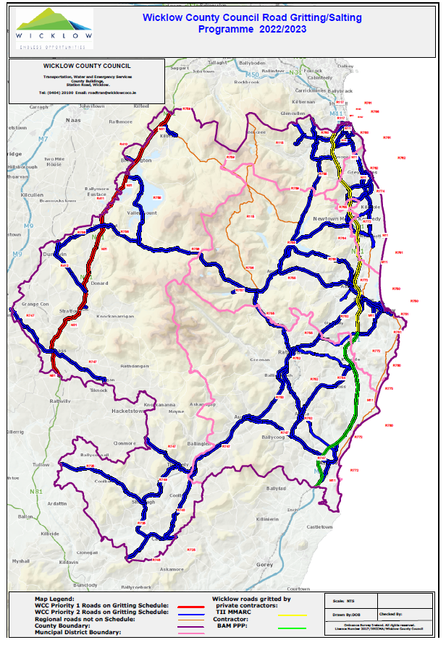

**APPENDIX 2 – STAFF RESPONSIBILITIES FOR PRIORITY ITEMS**

|  |  |  |
| --- | --- | --- |
| **Item Description** | **Person(s) Responsible for Overall Management & Co-ordination** | **Person(s) Responsible for Implementation** |
| Documented Risk Assessment of all Co. Wicklow gritting routes. | Winter Services Manager/Senior Engineer/Director of Services | MD Engineers |
| Conduct H&S Audit of gritting operations. | Winter Services Manager/Senior Engineer/Director of Services | EE or Technician, Roads Section Winter maintenance Manager has indicated audit is complete |
| Communication equipment & mobile phone coverage; identification & recording of coverage black spots in each Municipal District. | Winter Services Manager/Senior Engineer/Director of Services | MD Engineers |
| Salt Depot improvements including provision of suitable loading equipment. | Winter Services Manager/Senior Engineer/Director of Services | MD Engineers |
| Ensuring ongoing compliance with procedures in the Wicklow County Council Lone Working Policy document during the Winter Maintenance season. | Winter Services Manager/Senior Engineer/Director of Services | MD Engineers, GSS’s and/or MD Administrators |
| Ensuring ongoing staff working hour’s compliance with the regulations contained in the Working Time Act (1997) during the Winter Maintenance season. | Winter Services Manager/Senior Engineer/Director of Services | MD Engineers, GSS’s and/or MD Administrators |

**APPENDIX 3 – WICKLOW COUNTY COUNCIL DUTY ENGINEERS ROSTER**

Winter Service Duty Engineers’ Roster for the Period **17th October 2022 to 30th April 2023**

**Local Authority Name**: **WICKLOW COUNTY COUNCIL**

|  |  |  |  |  |  |  |  |
| --- | --- | --- | --- | --- | --- | --- | --- |
| **Week starting Monday** | **Duty Engineer’s Initials** | **Week starting Monday** | **Duty Engineer’s Initials** | **Week starting Monday** | **Duty Engineer’s Initials** | **Week starting Monday** | **Duty Engineer’s Initials** |
| 17/10/2022 | **DOB** | 12/12/2022 | **BOS** | 06/02/2023 | **CC** | 03/04/2023 | **DOB** |
| 24/10/2022 | **CC** | 19/12/2022 | **DOB** | 13/02/2023 | **BOS** | 10/04/2023 | **CC** |
| 31/10/2022 | **BOS** | 26/12/2022 | **CC** | 20/02/2023 | **DOB** | 17/04/2023 | **BOS** |
| 07/11/2022 | **DOB** | 02/01/2023 | **BOS** | 27/02/2023 | **CC** | 24/04/2023 | **DOB** |
| 14/11/2022 | **CC** | 09/01/2023 | **DOB** | 06/03/2023 | **BOS** |  |  |
| 21/11/2021 | **BOS** | 16/01/2023 | **CC** | 13/03/2023 | **DOB** |  |  |
| 28/11/2022 | **DOB** | 23/01/2023 | **BOS** | 20/03/2023 | **CC** |  |  |
| 05/12/2022 | **CC** | 30/01/2023 | **DOB** | 27/03/2023 | **BOS** |  |  |

|  |  |  |  |
| --- | --- | --- | --- |
| **Duty Engineer’s Name & Initials** | **Office Phone No** | **Office E-mail Address** | **Mobile No** |
| **Conor Carty (CC)** | 0404 20100 |  |  |
| **Declan O’ Brien (DOB)** | 0404 20100 |  |  |
| **Brian O’ Sullivan (BOS)** | 0404 20100 |  |  |
| **Pat Clarke (PC)** *-* ***Winter Service Manager*** | 0404-20100 |  |  |

*Send to: CAFO, Met. Éireann, Glasnevin Hill, Dublin 9. Attention: Duty SMO.*

*Copy to: Owen Smith, Transport Infrastructure Ireland, Parkgate Business Centre, Parkgate Street, Dublin 8.*

# APPENDIX 4 - DRIVER’S ROSTER

|  |  |  |  |  |  |
| --- | --- | --- | --- | --- | --- |
| **Drivers - Black**  **Helpers – Red**  **Approximate Drive Time - Blue** | | | | | |
| **Area** | **Driver(s)** | **Period** | **Area** | **Driver(s)** | **Period** |
| **Baltinglass Municipal District**  *(N81 & Baltinglass Route)*  **2.5 hrs** |  | October 2022–  April 2023 | **Arklow Municipal District**  *(Arklow/Avoca Route)*  **2hrs 45 mins** |  | October 2022–  April 2023 |
| **Baltinglass Municipal District**  *(N81 & Blessington Route)*  **2.5hrs** |  | October 2022–  April 2023 | **Arklow Municipal District**  *(Aughrim Route)*  **2hrs 45 mins** |  | October 2022–  April 2023 |
| **Baltinglass Municipal District**  *(Tinahely Route)*  **2.0hrs** |  | October 2022–  April 2023 | **Wicklow Municipal District**  *(Ashford Route)*  **3.5 hrs** |  | October 2022–  April 2023 |
| **Greystones Municipal District**  *(Greystones Route)*  **3.0 - 3.5hrs** |  | October 2022–  April 2023 | **Wicklow Municipal District**  *(Roundwood Route)*  **4.0hrs** |  | October 2022–  April 2023 |
| **Relief Drivers** |  | October 2022–  April 2023 | **Bray Municipal District**  *(Enniskerry Route)*  **3.0hrs** |  | October 2022–  April 2023 |

**OUTLINE OF DUTIES FOR HELPER**

1. Assisting drivers in winter maintenance duties
2. Assisting in Loading of gritters onto trucks
3. Assisting in Loading of salt onto gritters
4. Opening/closing depots
5. Assisting in removal of covers from salt stockpiles and return of same
6. Assisting in fuelling of trucks and gritters
7. Washing down of trucks and gritters post salting
8. Assisting in providing Lone workers arrangements for drivers
9. Available to assist drivers in event of breakdown.

Please note duties of helpers are subject to change due to Covid 19 regulations

|  |  |  |
| --- | --- | --- |
| ***Emergency Services*** |  |  |
| *Ambulance Service* |  | 999 or 112 |
| *Fire Service* |  | 999 or 112 |
| *Bray Fire Service* |  | 01-2861534 |
| *Gardai* |  | 999 or 112 |
| *Bray Garda Station* |  | 01-6665300 |
| *Civil Defence* |  | 086-8183358  087-2690615 |

# APPENDIX 7 - WINTER SERVICE DEPOT DETAILS & LOCATION MAP

|  |  |  |  |  |  |  |  |
| --- | --- | --- | --- | --- | --- | --- | --- |
| **Ref** | **Salt Depot** | **GPS Coords** | **Depot Supervisor Name** | **Mobile** | **Indoor Capacity**  **(Tonnes)** | **Outdoor Capacity**  **(Tonnes)** | **Depot Storage Capacity**  **(Tonnes)** |
| WW01 | Killadrennan | 53.0728, -6.09429 |  |  | 600 | 150 | **750** |
| WW02 | Baltinglass | 52.9323, -6.68094 |  |  | 0 | 600 | **600** |
| WW03 | Blessington | 53.1704, -6.5447 |  |  | 0 | 1,000 | **1,000** |
| WW04 | Shillelagh/ Carnew Road | 52.7536, -6.5331 |  |  | 0 | 800 | **800** |
| WW05 | Roundwood | 53.0524, -6.23787 |  |  | 0 | 400 | **400** |
| WW06 | Avoca | 52.8715, -6.21997 |  |  | 0 | 500 | **500** |
| **TOTAL** | | | | | | | **4,050** |

